|  |
| --- |
| http://image.slidesharecdn.com/ejerciciosdearreglo-120715020722-phpapp02/95/ejercicios-de-arreglo-6-728.jpg?cb=1342336080 |

**VECTOR #1**

|  |  |  |  |
| --- | --- | --- | --- |
| L | I | v | VA |
|  | 1 | 9 | 9 |
|  | 2 | 5 | 5 |
| 3 | 3 | 8 | 8 |

**VA**

|  |  |  |
| --- | --- | --- |
| 9 | 5 | 8 |

**VB**

|  |  |  |
| --- | --- | --- |
| 81 | 25 | 64 |

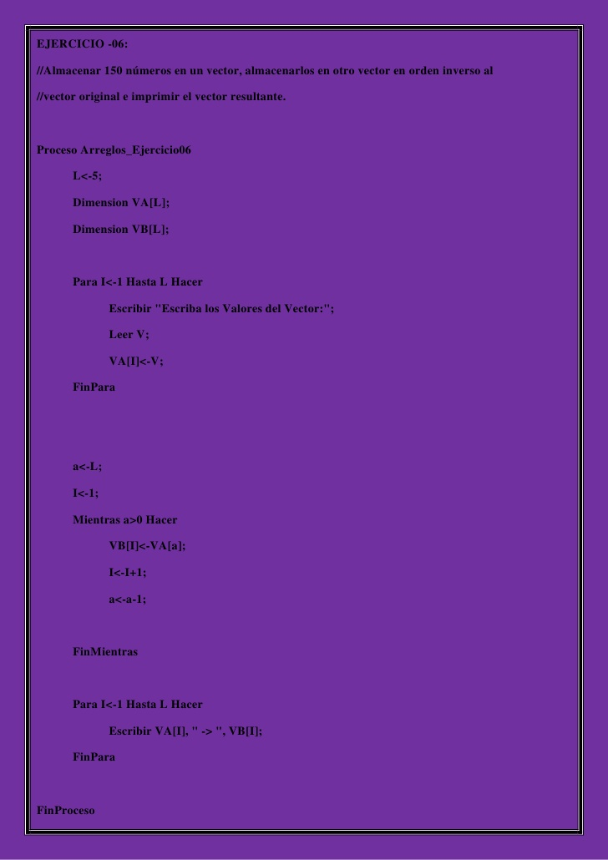

**VECTOR # 2**

|  |  |  |  |
| --- | --- | --- | --- |
| L | I | V | VA |
|  | 1 | 7 | 7 |
|  | 2 | 55 | 55 |
|  | 3 | 20 | 20 |
|  | 4 | 9 | 9 |
| 5 | 5 | 6 | 6 |

**VB**

|  |
| --- |
| 6 |
| 9 |
| 20 |
| 55 |
| 7 |